**Mango Quality Classification**

**Nguyen Quang Hiep (Team leader); Bui Phi Hung; Nguyen Minh Quan**

**Advisor: Luong Trung Kien**

**Abstract:** Mango is one of the leading exported fruits in Vietnam. With mango production increasing year by year, it is essential to choose good quality mangoes. Thanks to the great development of technology, this problem has also been partially solved. In this report, we provide a computer program to classify mango fruit quality and status based on color. For the best classification results, we decided to focus on a single mango variety, Cat Chu. We approached this report from many different angles and levels, including data collection, data labeling, data aggregation and processing......

**Keywords:** Mango, classification, pixel, detection, quality

**1. Introduction**

Vietnamese agricultural products in general and mangoes in particular have been contributing an important part in the country’s economy. In Vietnam, the total area of mango cultivation is about 87,000 hectares with a huge output of more than 893,000 tons/year. [1] Large enterprises are now very interested in improving the quality and value of mangoes, in order to penetrate difficult but potential markets such as the US, Korea, and Japan. But the assessment of mango quality in Vietnam has not been applied much technology, most of it is still manual. Therefore, we make this product with the aim to increase productivity, increase product quality and especially reduce labor costs.

With those problems in mind, we would like to propose a small project to solve this problem. By a classification model like [2] “Graduation project of sorting mango” with our software. The input data will be 4 pictures corresponding to 4 sides of a mango. We will analyze, process and classify pixels with Computer Vision’s classification method. The output data will be the status of the mango: green, nursery, ripe, damaged.

In order for the results to be classified in the most accurate way, our team only focused on a single mango variety, Cat Chu.

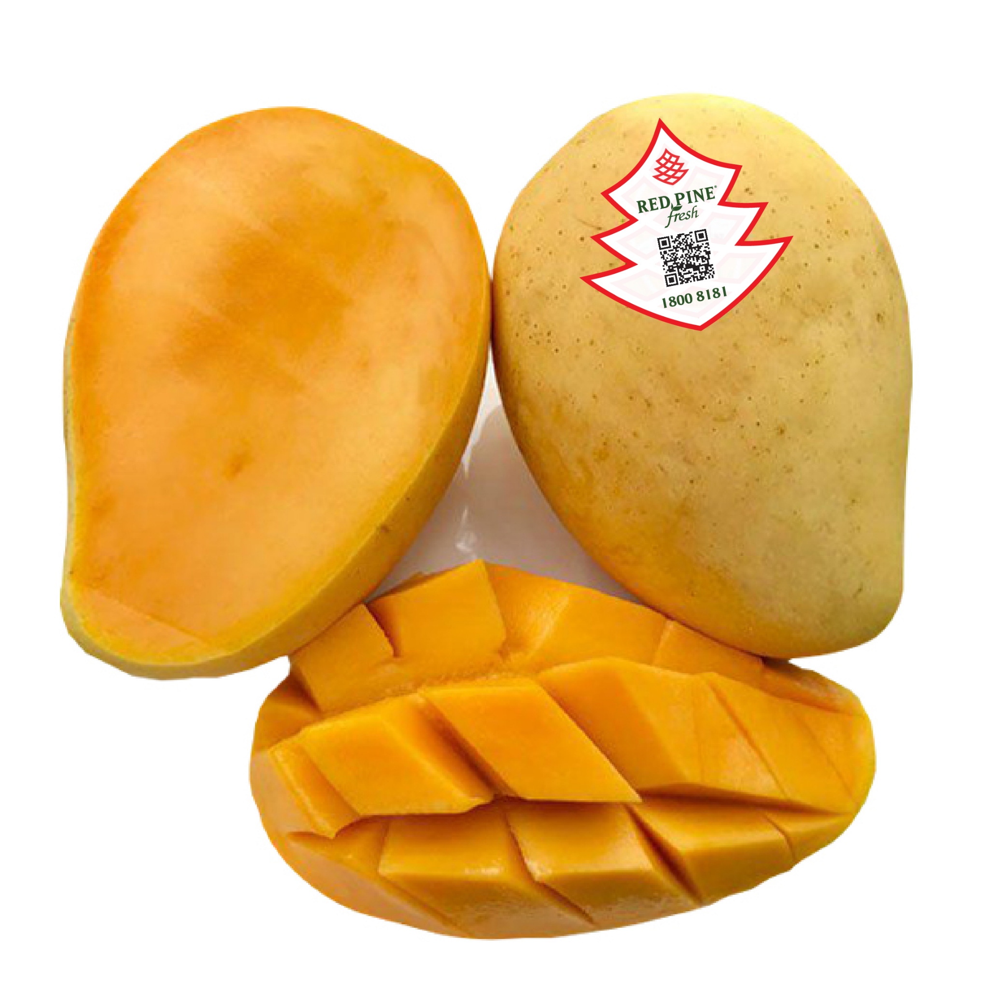

**Some Remarks:**

Our task in this project is to develop a program based on Computer Vision with classification methods. The program will analyze the image of a mango and return the status of that fruit quickly and accurately.

**2. Related Works**

[1] Vietnam's mango exports: [Vietnam's mango exports](https://www.vietnamplus.vn/bao-duc-viet-nam-se-tang-gap-doi-luong-xoai-xuat-khau/780951.vnp#:~:text=B%C3%A0i%20b%C3%A1o%20d%E1%BA%ABn%20s%E1%BB%91%20li%E1%BB%87u,so%20v%E1%BB%9Bi%20n%C4%83m%20tr%C6%B0%E1%BB%9Bc%20%C4%91%C3%B3.)

[2] Graduation project of sorting mango: [Sorting mango](https://www.youtube.com/watch?v=U0dtdjvFY3Q)

[3] Classification and Grading of Harvested Mangoes:[Classification and Grading Mango](https://www.tandfonline.com/doi/pdf/10.1080/15538362.2021.2023069)

[4] Cdiscount image classification:[Cdiscount image classification.pdf](https://drive.google.com/file/d/1-9AnaAjbfryTLwxQXG54aa2D25kgPsww/view?usp=sharing)

[5] Object Detection:[Object Detection](https://viso.ai/deep-learning/object-detection/)

**Some Remarks:**

[3] The approach is to use CNN to classify eight mango varieties based on quality characteristics such as color, size, shape, and texture. Data are horizontal rotate, translate, zoom, crop and flip images of 8 popular mango varieties collected from Haji Ghulam Muhammad - Mangana Mango Garden in Multan, Pakistan for database collection. As a result, the proposed method achieves classification accuracy of up to 99.2% and classification accuracy of 96.7%. The limitation is that while optimizing the model, in some cases, the model is confused in two classes (Type I) and (Type II) because the similarity of defective mangoes in both types has caused problems. wrong problem.

[4] The project approach is to use transfer learning and fine-tuning on pre-trained networks such as ResNet50 and VGG-19, available in Keras. Data is a 58GB compressed file with a total of 7 million products represented by more than 12 million images (~350Gb when decompressed), with more than 5000 layers. Test data set includes 1.7 million products with 1-4 photos for each product. As a result, the best Accuracy they achieved was 0.73 and the worst was 0.55. The drawback is that they experience memory errors in the prediction process and also have problems with prediction speed and overfitting.

[5] The approach is to use the R-CNN algorithm in object detection. In R-CNN models, it is common to extract the most necessary features of the object (usually about 2000 features) using a selective algorithm (called selective search). The process of selecting the most important features can be computed with the help of a selective search algorithm. The extraction of region proposal regions is done through the Selective Search algorithm to extract regions that are likely to contain objects (about 2000 regions). Then, these regions (images) are resized to a fixed size and passed through a pre-trained CNN model (imagenet), and then proceed to determine offsets and object labels. The drawback is that putting the region proposal areas through the CNN network 2000 times makes the execution speed of the model extremely slow. The end result is to create many popular algorithms for each purpose: YOLO, R-CNN, Mark R-CNN, MobileNet, SqueezeDet.

**3. Data Preparation**

The purpose of this project was to develop a machine learning model capable of classifying mangoes into one of four categories: "green_bad", "green_good", "yellow_bad", or "yellow_good". To obtain the necessary data for training the model, we captured images of mangoes in different states. Specifically, we took four cross-sectional pictures of each mango. To increase the size of our dataset and improve the accuracy of our model, we used Numpy and PIL to rotate and flip the original photographs, creating additional data for analysis.

The images were square RGB (red-green-blue) images, with each image labeled with one of the four categories. The dataset consisted of 1,740 images, with 300 images reserved for testing, 180 for validation, and the remaining 1,560 for training. Specifically, we collected 300 images for the green bad class, 600 for the green good class, 240 for the yellow bad class, and 600 for the yellow good class.

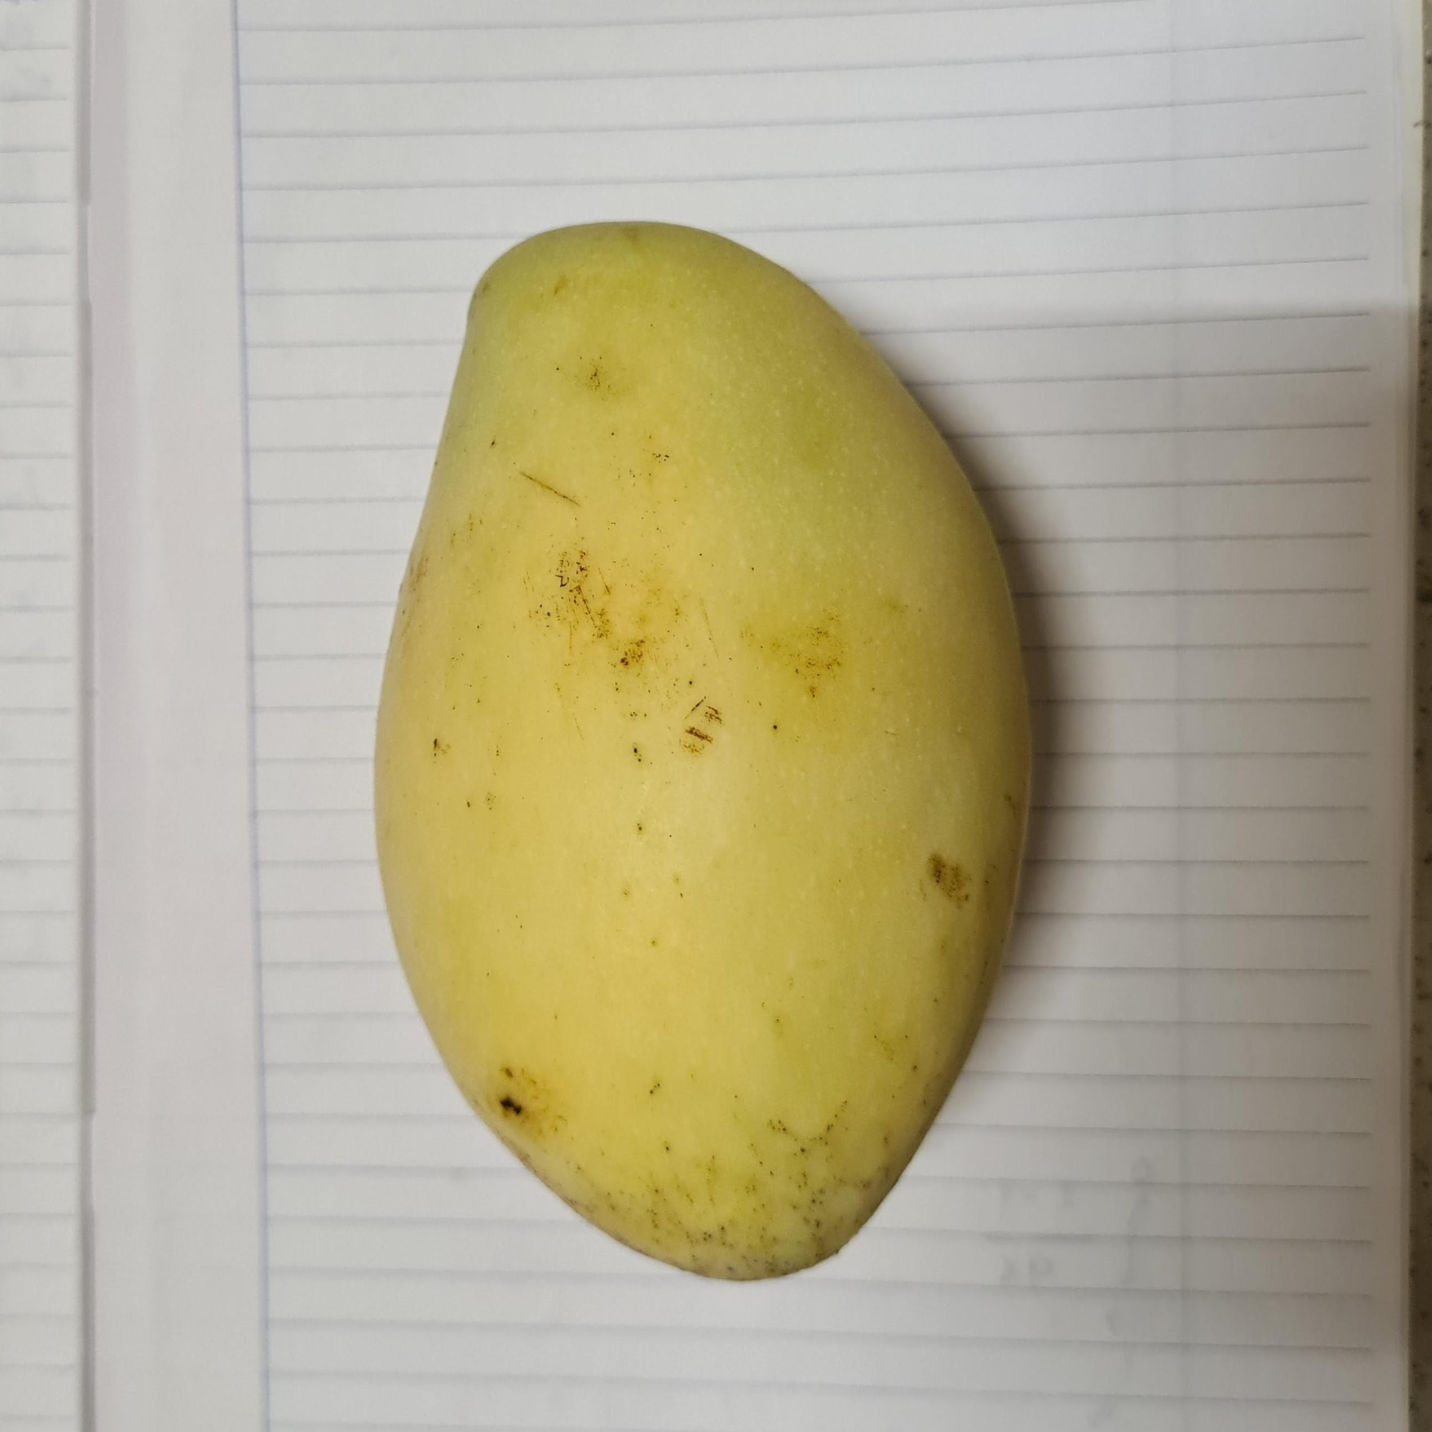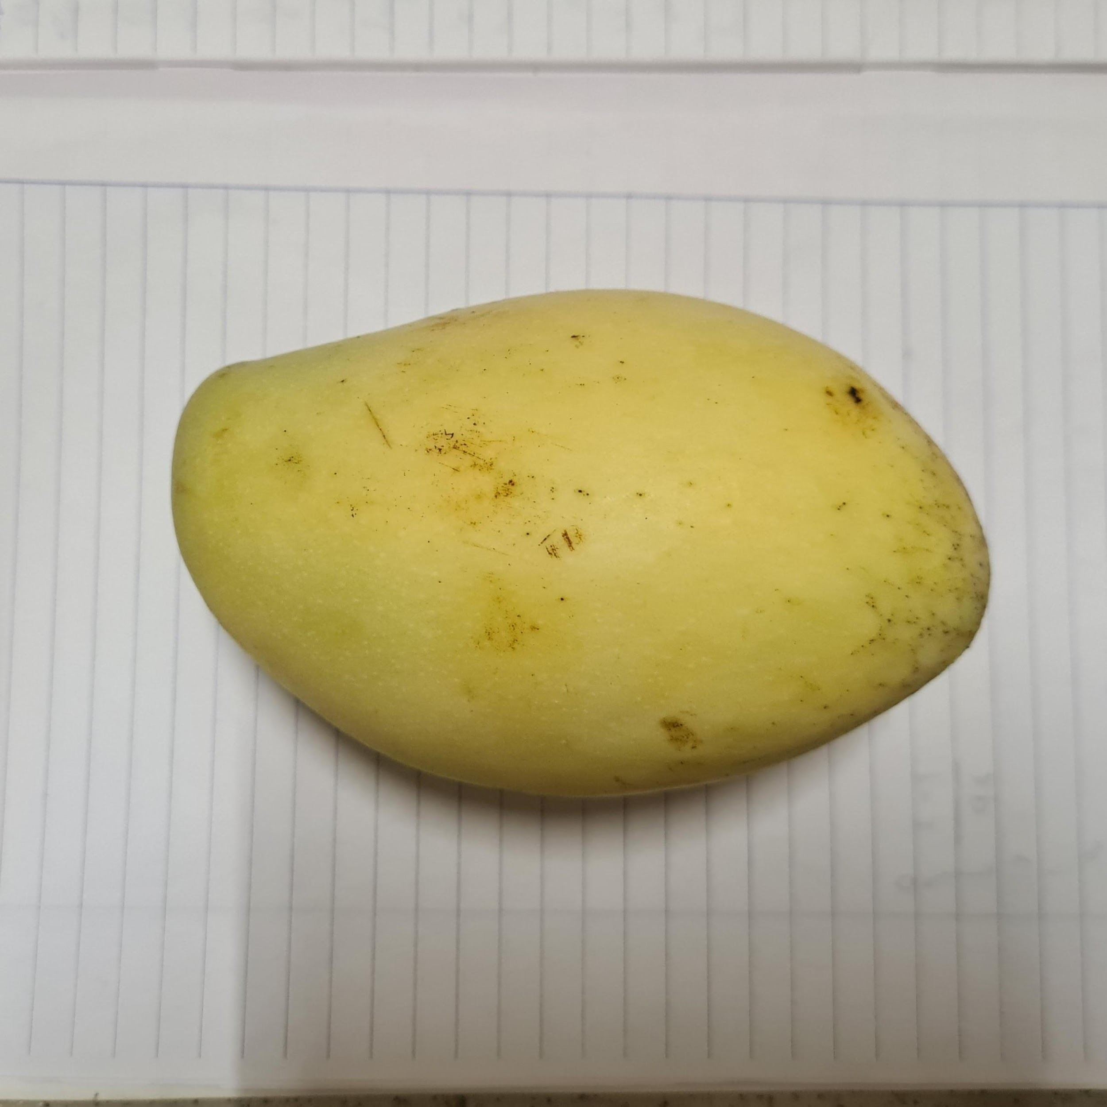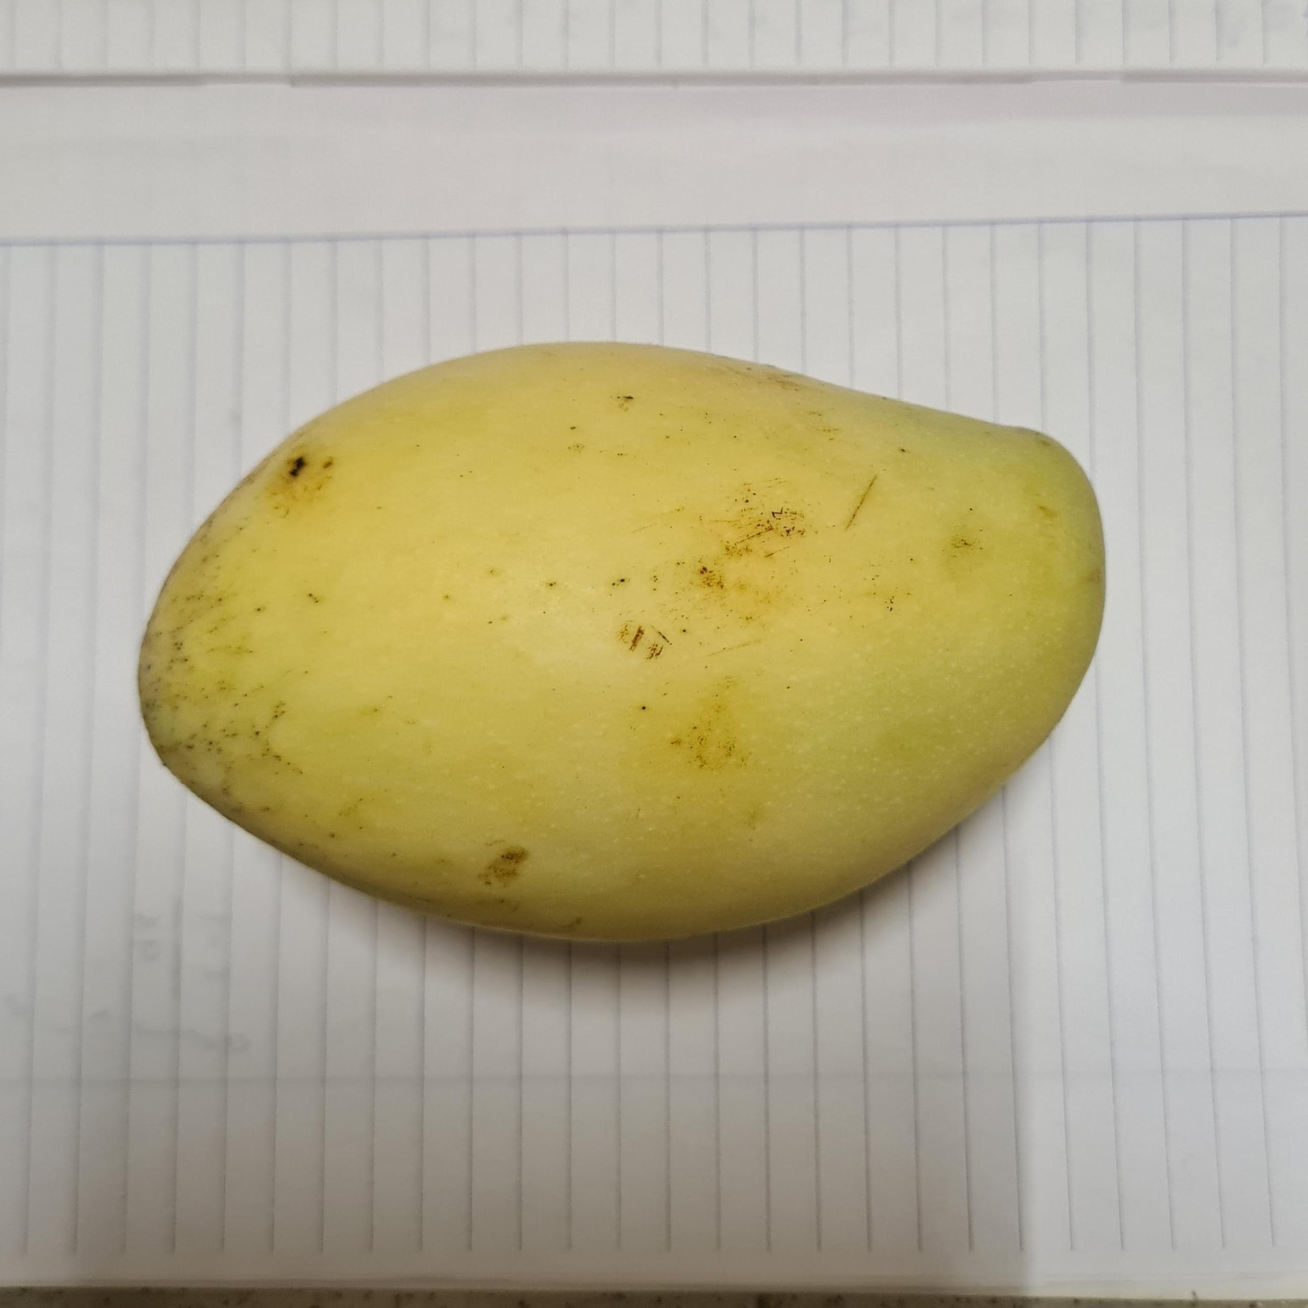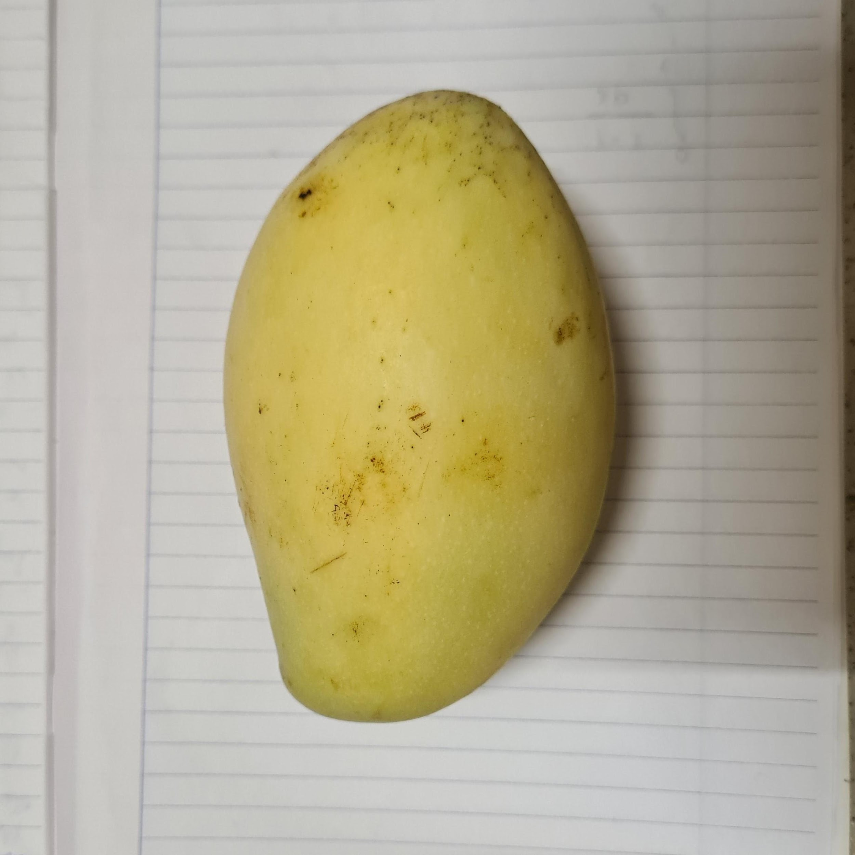

*Picture of ripe mango*

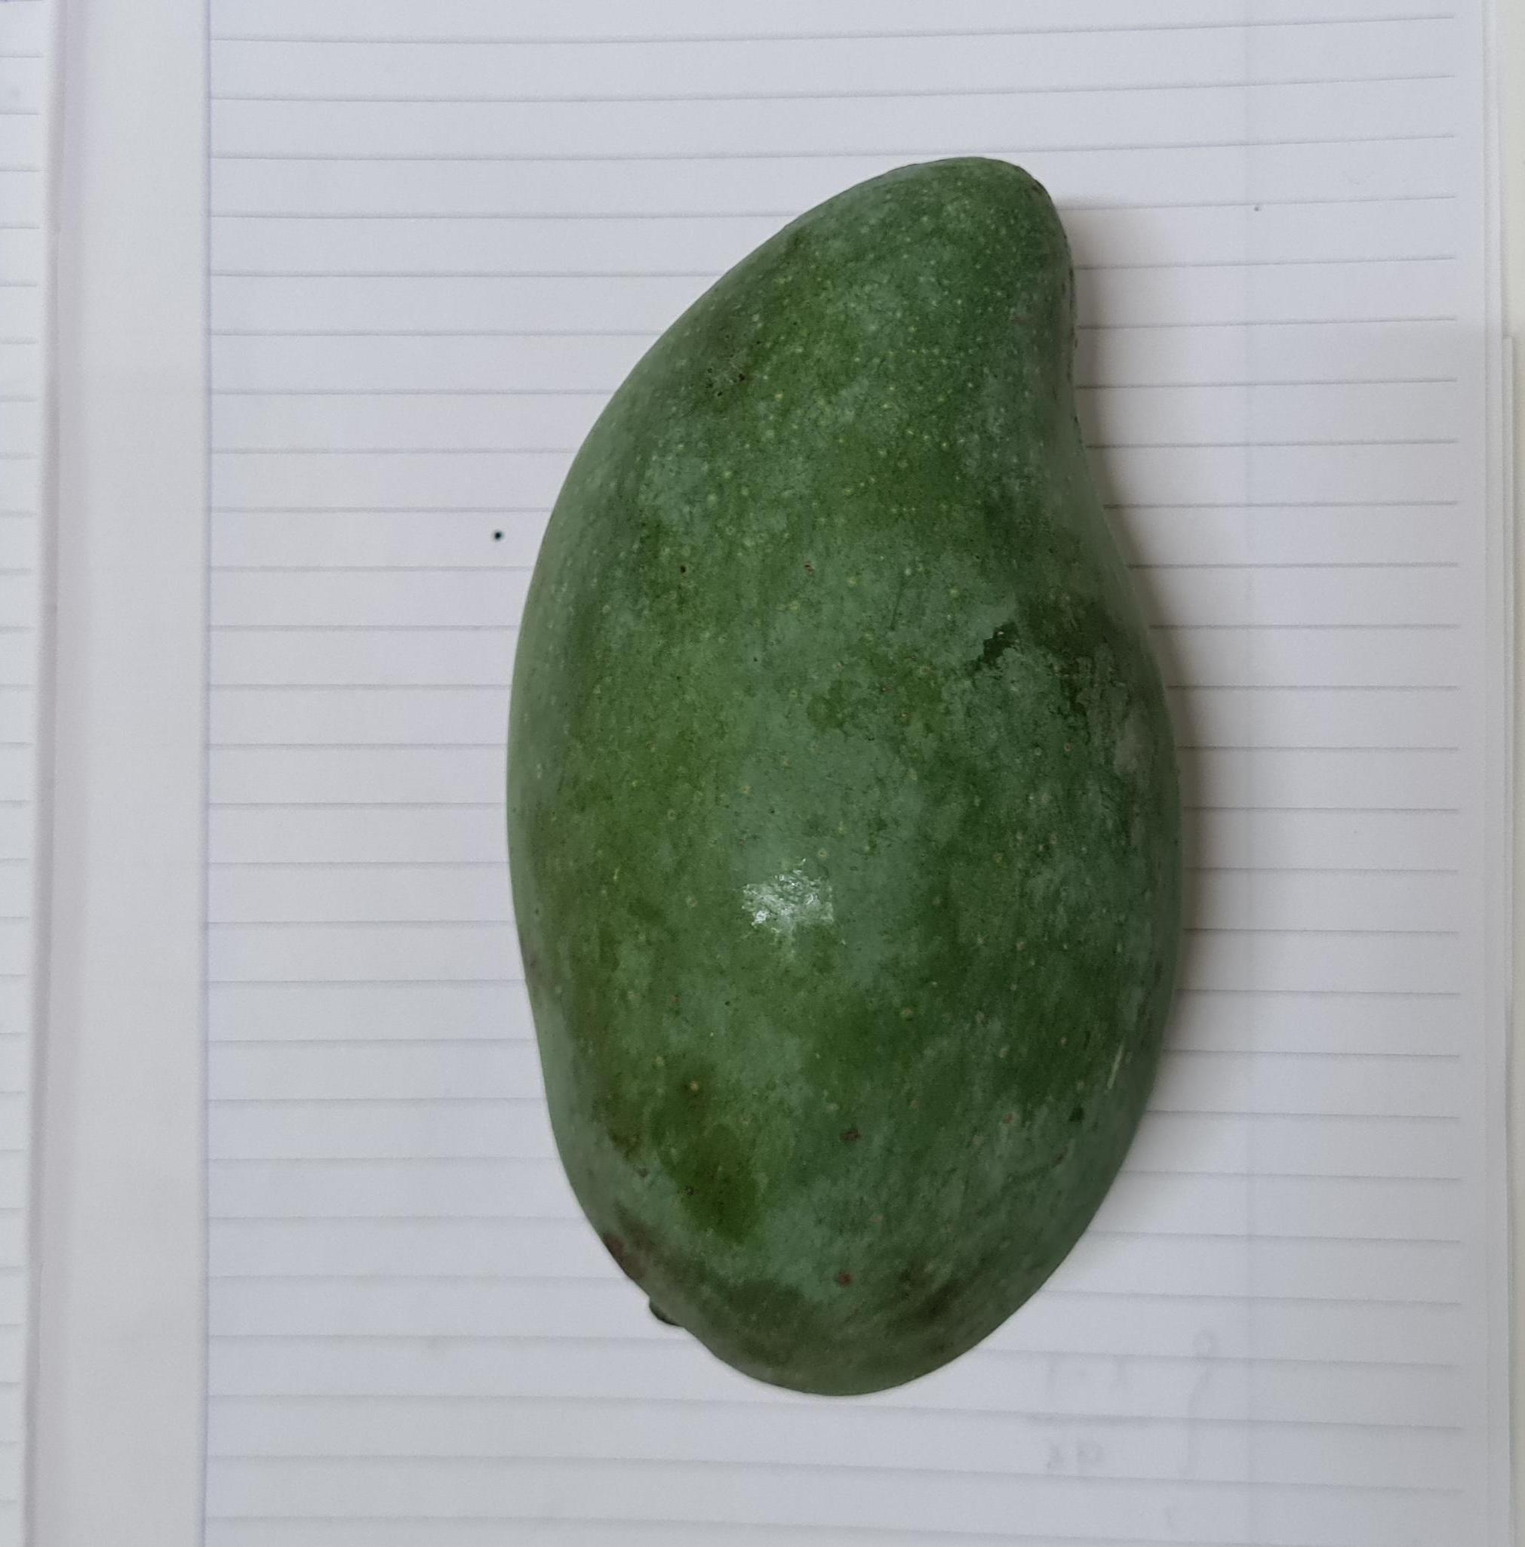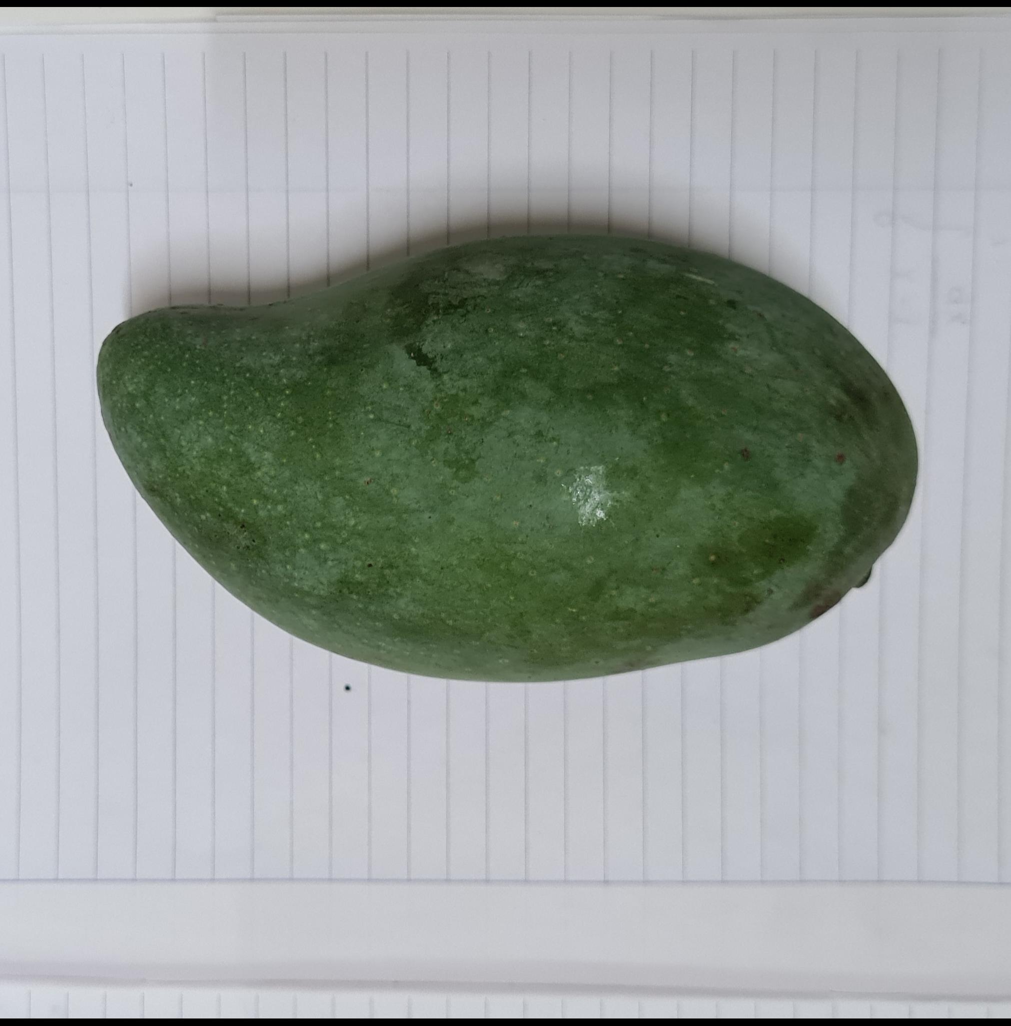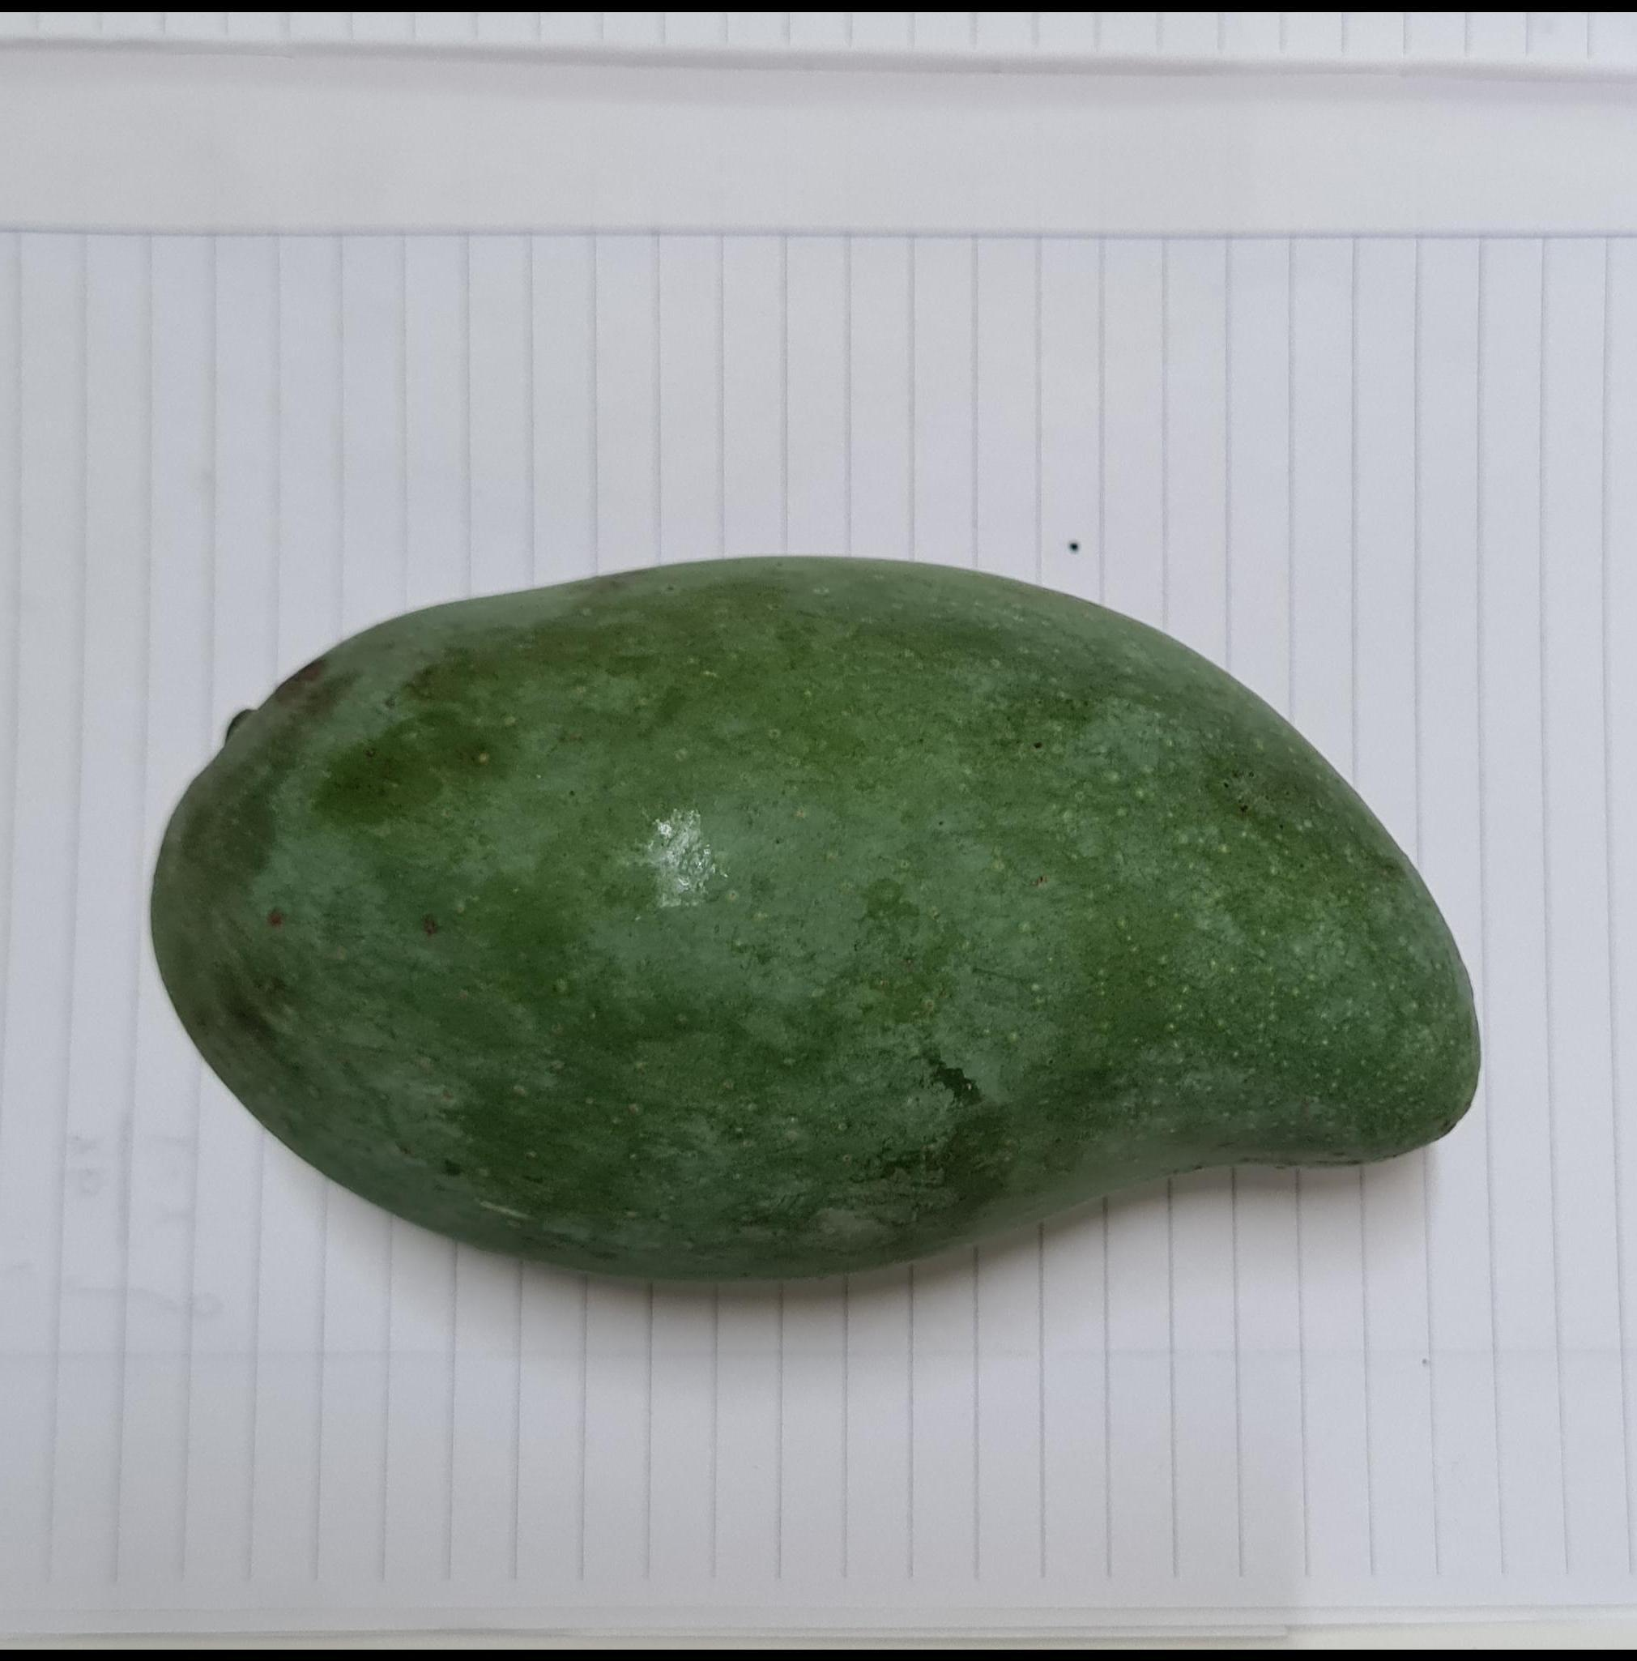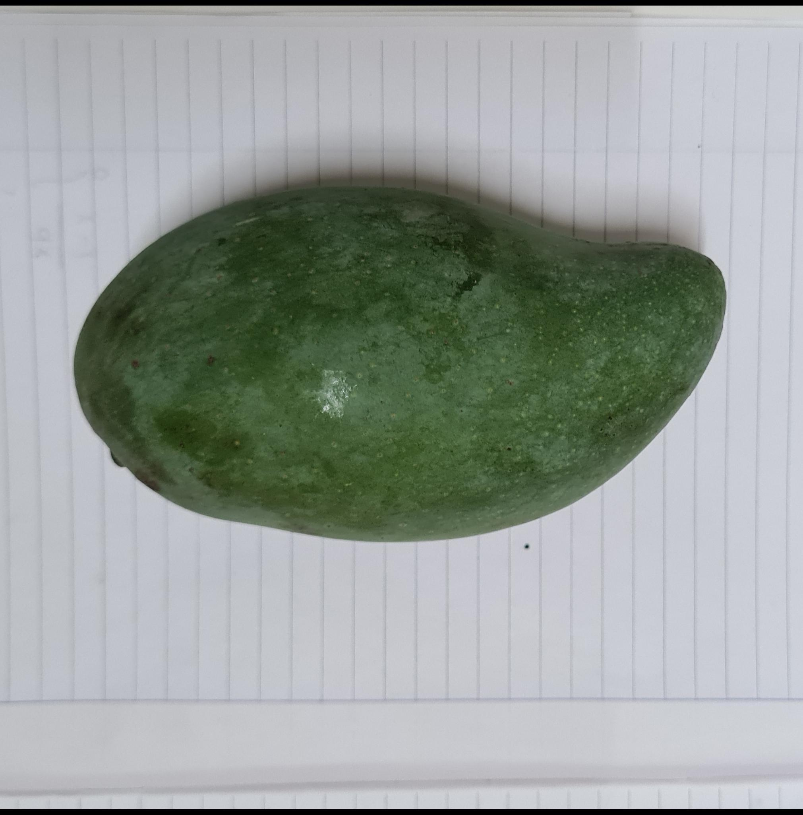

*Picture of raw mango*

To ensure the quality and consistency of our dataset, we carefully selected and adjusted the images. This involved removing any images that were of poor quality or did not fit the criteria for each category. We also standardized the size and resolution of the images and ensured that each image was correctly labeled.

Overall, the data collection and processing steps were critical for building a robust and accurate machine learning model. By carefully selecting and adjusting the dataset, we were able to improve the performance of our model and ensure that it was capable of accurately classifying mangoes into the desired categories.

**4. Methods**

We are using the Convolution Neural Network (CNN) for classifying mangoes based on their quality. The model accepts RGB images of 255x255 dimensions as input and MangoModel consists of two Convolutional layers with batch normalization, two ReLU activation, followed by two max-pooling layers, a fully connected layer with batch normalization and ReLU activation, a dropout layer, and a final fully connected layer for classification:

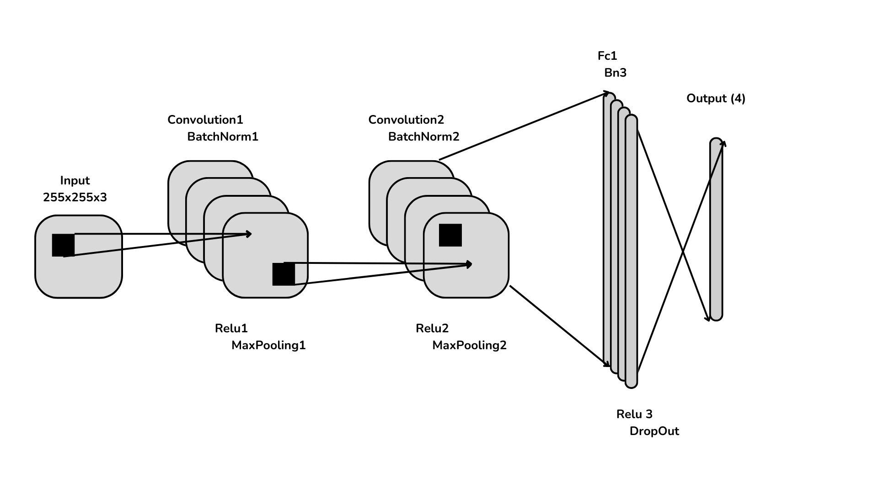

* The first layer, Conv1, is a 2D Convolution layer that takes in an input image with 3 color channels (RGB) and applies 16 filters of size 3x3 with a stride of 1 and padding of 1. This results in 16 feature maps that are the same size as the input image.
* The second layer, bn1, is a batch normalization layer that normalizes the outputs of Conv1. Batch normalization can improve the stability and speed of the training process.
* The third layer, relu1, applies the ReLU activation function to the output of bn1. ReLU returns the input value if it is positive, and 0 otherwise. This creates a piecewise linear function that is very simple to compute and can improve the performance of deep neural networks.
* The fourth layer, pool1, is a max-pooling layer that reduces the size of the feature maps by taking the maximum value of non-overlapping regions of size 2x2. This helps to reduce the number of parameters in the model and can help prevent overfitting.
* The next layers, Conv2, bn2, relu2, and pool2, repeat the same process as the first four layers but with 32 filters in Convolution. This results in 32 higher-level feature maps.
* The seventh layer, fc1, is a fully connected layer with 64 output neurons. It takes the flattened feature maps from the previous layer and applies a linear transformation to produce a 64-dimensional feature vector. Followed by bn3, is a batch normalization layer, relu3 applies the ReLU activation function and Dropout, applies dropout regularization with a probability of 0.5 to prevent overfitting by randomly setting some of the outputs of the previous layer to zero during training.
* The eleventh layer, output, is a fully connected layer with 4 output neurons, which corresponds to the number of classes in the classification problem and returns the probability of each class.

Overall, our MangoModel is a relatively simple but effective CNN architecture for image classification problems, and can be used as a starting point for more complex models.

To predict the most accurate way, our MangoModel predicts the status of a mango based on four cross-sectional images of the fruit. The model analyzes each image to make its predictions. The output of the model will give us the probability of each label: 0 - "green_bad", 1 - "green_good", 2 - "yellow_bad", 3 - "yellow_good". After that, we take the average probability of each label from all images. This will give us the most accurate prediction of the mango's status.



**5. Result and discussion**

Convolution Neural Networks are very strong in image classification which is suitable for our project problem so we have builded three models based on it.

The modified pretrain model VGG19 was the first model we trained to recognize fruit quality. Our team trained the VGG19 for 10 separate epochs and obtained results with an overall accuracy of 80%. However, during testing, we noticed that the model had difficulty classifying two specific classes: "green_bad" and "green_good." It's important to note that the original VGG model was not specifically designed for fruit quality recognition. As a result, our team encountered challenges in adjusting the model to perform well in this task. We attempted to improve the model's performance by adjusting the parameters of the added layers and even tried unfreezing a few of the last layers of VGG. Unfortunately, these attempts did not yield significant improvements.

After several unsuccessful attempts to modify the VGG19 model, we made the decision to build our own model base using the Keras layer of TensorFlow. We believed that our newly developed model would produce better results and improve the accuracy of our classification. However, we encountered difficulty in setting up the necessary environment to train the model on a GPU, and therefore resorted to training it on a CPU. The model was trained for a total of 8 hours with early stopping that involves monitoring the model's performance on a validation set during training, if the performance of the model on the validation set stops improving or starts to deteriorate, the training is stopped early to prevent overfitting. Although the model performed well on the test set with an accuracy rate of 98%, the model failed to accurately predict these new images. We failed to prevent it from being overfitting.

The final model we settled on for our project is built using PyTorch, which is a popular machine learning framework. One of the advantages of using PyTorch is its ease of installation, compared to other frameworks like Tensorflow. Additionally, PyTorch requires less computational resources to train models, which makes it a more accessible option for developers with limited resources. During the training process, we used a check_point to periodically save the model's parameters, which allowed us to resume training from the most recent checkpoint in case of any interruptions. The result of our efforts was a highly accurate model that achieved a 96% prediction accuracy on the test set. Furthermore, our model demonstrated good generalization performance on unseen data, indicating that it can effectively generalize its learnings to new data points. Overall, we are confident in the reliability and effectiveness of our PyTorch model for our project's needs.

**6. Conclusion**

In summary, the mango detection project has achieved positive results in classifying the quality of mangoes on images. By using image processing and deep learning techniques, we have built a model that accurately classifies the condition of the mango.

To achieve this result, we collected and prepared the appropriate data, performed the data preprocessing steps, created and trained a deep learning model, and tested the model on the test dataset. . The obtained results have been evaluated and compared with other models, and have shown the efficiency and accuracy of our model.

However, the project still has many opportunities for future development and improvement. For example, improving model accuracy by using new techniques and improving data preprocessing. Or maybe extend the project to detect other fruits.

Overall, the project has achieved its goal and brought practical value in detecting mangoes in images, and opened up many opportunities for similar research and applications in the future.

# Appendix A. Project Plan management

| Task Name | Priority | Owner | Start date | End date | Status | Issues |
| --- | --- | --- | --- | --- | --- | --- |
| Find documents | High | All team | 4/1/2023 | 11/1/2023 | Finished | N/A |
| Review related papers | High | Bui Phi Hung,  Nguyen Quang Hiep | 11/1/2023 | 31/1/2023 | Finished | N/A |
| Collect data and data processing | High | Nguyen Quang Hiep, Nguyen Minh Quan | 8/2/2023 | 13/2/2023 | Finished | N/A |
| Evaluate potential method | High | Bui Phi Hung | 13/2/2023 | 20/2/2023 | Finished | N/A |
| Experiment | High | Bui Phi Hung | 20/2/2023 | 5/3/2023 | Finished | N/A |
| Compare results | High | Nguyen Quang Hiep | 6/3/2023 | 9/3/2023 | Finished | N/A |
| Writing report | High | Nguyen Quang Hiep, Nguyen Minh Quan | 10/3/2023 | 17/3/2023 | Finished | N/A |

# Appendix B. Source code & Data

| Item | Link | Description |
| --- | --- | --- |
| Data | <https://drive.google.com/drive/folders/1q_qbWyMozvu3giyqtQsfuGNj12rg0QjF?usp=sharing> | From real data |
| Source Code | <https://github.com/nohope-n3/Mango-Quality-Detection.git> | Github Project |
| Drive | <https://drive.google.com/drive/folders/1YDk5HRR8pyxe8HJZHWfBPIKFLg0L8rWY> | Related paper  Report |